**Task 1**

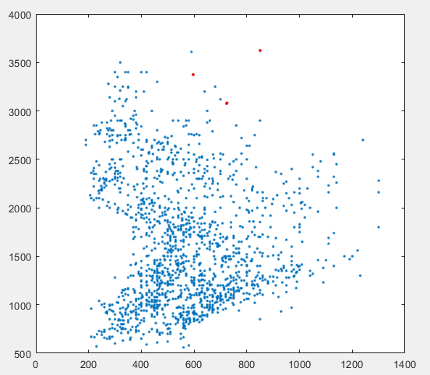

load('PB12.mat');

load('PB_data.mat');

J = f1;

J(:,2) = f2;

plot(J(:,1),J(:,2), ' .');

**Task 2**

To make x the data set for a selected phoneme.

phoneme = 1;

temp = [phno,J];

temp(temp(:,1) ~= phoneme, :) = [];

x = temp(:,2:3)

k = 3

The was very consistent in the location it identified for the clusters at a k = 3. Run results were all extremely similar.

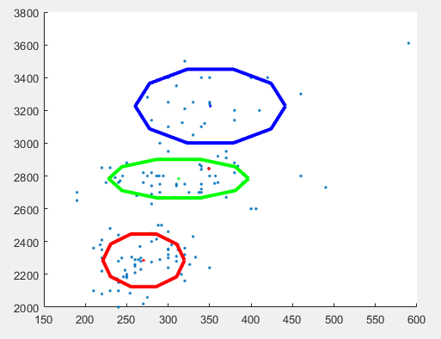 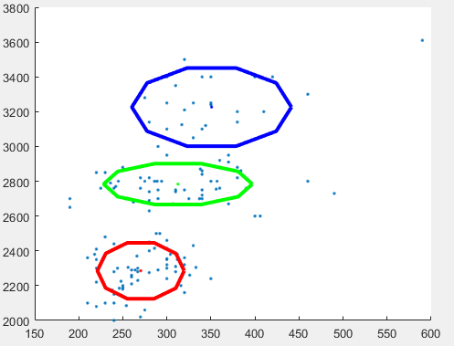

MoG Model Phoneme 1 k = 3

*mu*

1.0e+03 *

0.3508 0.2704 0.3126

3.2263 2.2855 2.7839

*s2*

(:,:,1) =

1.0e+04 *

0.4103 0

0 2.7830

(:,:,2) =

1.0e+04 *

0.1214 0

0 1.4278

(:,:,3) =

1.0e+03 *

3.5626 0

0 7.6578

*p*

0.1839 0.4351 0.3810

At k = 6 there was far more variance in the final results. In addition to sometimes finding overlapping clusters.

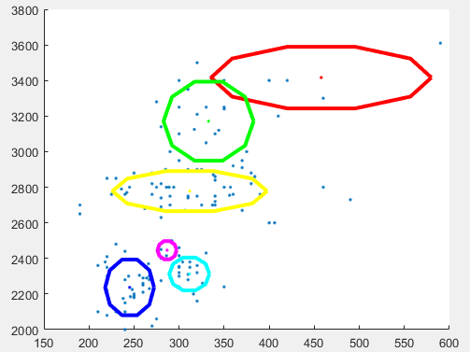 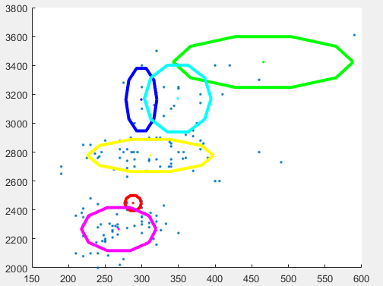

This indicates to me that 6 is probably too many clusters to search for in this dataset.

*mu*

1.0e+03 *

0.2965 0.4677 0.2449 0.3119 0.2808 0.3459

3.1462 3.4250 2.1543 2.7774 2.3375 3.1816

*s2*

(:,:,1) =

1.0e+04 *

0.0168 0

0 2.4986

(:,:,2) =

1.0e+04 *

0.7527 0

0 1.7344

(:,:,3) =

1.0e+03 *

0.2830 0

0 7.2432

(:,:,4) =

1.0e+03 *

3.6978 0

0 6.8953

(:,:,5) =

1.0e+03 *

1.2183 0

0 6.9907

(:,:,6) =

1.0e+04 *

0.1105 0

0 2.8344

*p*

0.0449 0.0228 0.1255 0.3656 0.3086 0.1326

Phoneme 2 didn’t behave as consisted at k = 3. The results were mostly similar but sometimes gave a extremely anomalous result.

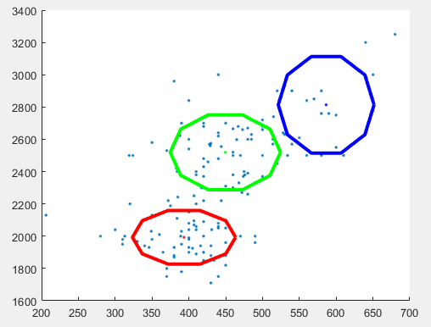 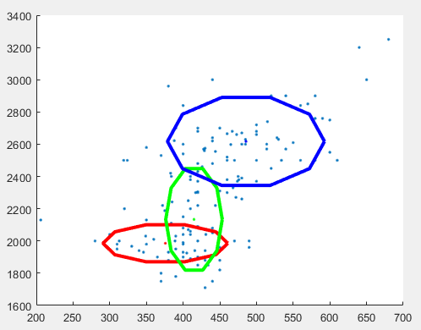

Normal result Anomalous result

*MoG model of Normal Result Phoneme 2 k = 3*

*mu*

1.0e+03 *

0.4494 0.3934 0.5860

2.5190 1.9928 2.8120

*s2*

(:,:,1) =

1.0e+04 *

0.2790 0

0 2.9782

(:,:,2) =

1.0e+04 *

0.2456 0

0 1.5213

(:,:,3) =

1.0e+04 *

0.2129 0

0 4.9421

*p*

0.4692 0.4346 0.0961

*MoG model of Anomalous Results Phoneme 2 k = 3*

*mu*

1.0e+03 *

0.3758 0.4148 0.4857

1.9856 2.1338 2.6173

*s2*

(:,:,1) =

1.0e+03 *

3.6202 0

0 7.2884

(:,:,2) =

1.0e+04 *

0.0742 0

0 5.4796

(:,:,3) =

1.0e+04 *

0.5723 0

0 4.1122

*p*

0.2137 0.3388 0.4474

Phoneme 2 at k = 6 was extremely erratic with no run looking similar to previous runs. Evening failing on the occasional run.

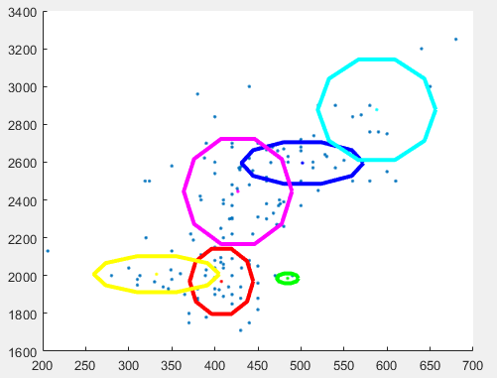 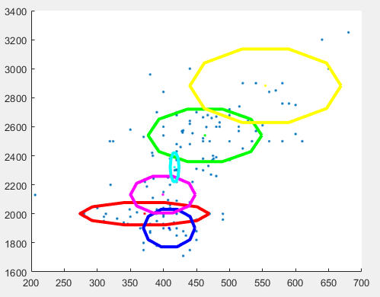

*MoG model of Result Phoneme 2 k = 6*

*mu*

1.0e+03 *

0.3716 0.4629 0.4087 0.5543 0.3992 0.4169

2.0008 2.5406 1.9019 2.8825 2.1325 2.3211

*s2*

(:,:,1) =

1.0e+03 *

4.7928 0

0 3.2795

(:,:,2) =

1.0e+04 *

0.3700 0

0 1.8059

(:,:,3) =

1.0e+03 *

0.7624 0

0 9.2258

(:,:,4) =

1.0e+04 *

0.6537 0

0 3.5425

(:,:,5) =

1.0e+03 *

1.2003 0

0 8.7890

(:,:,6) =

1.0e+03 *

0.0221 0

0 5.3580

*p*

0.1458 0.4064 0.1785 0.0933 0.1204 0.0556

**Task 3**

**Task 4**

**Task 5**